**Clothing store projects Tests**

For our clothing store project we decided to test all the functionalities by the selenium IDE. Selenium is a very reliable testing software for test all the functionalities of the project.

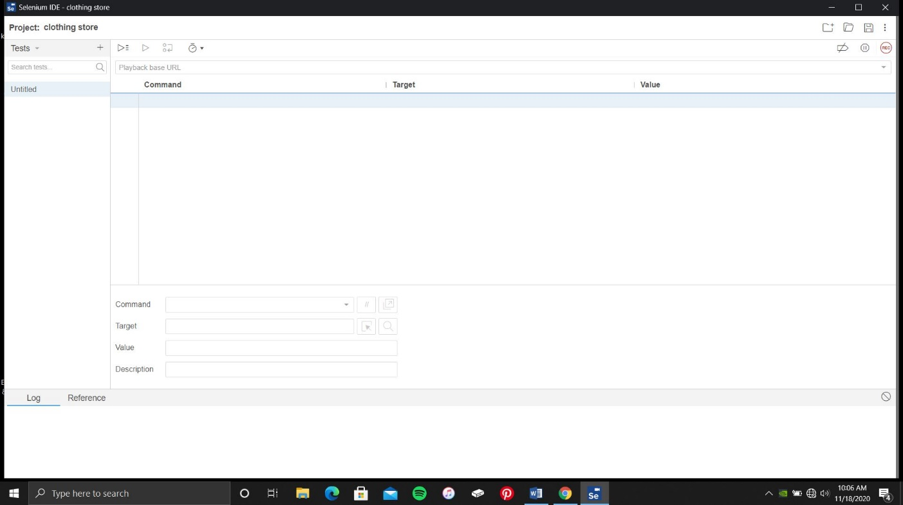

1. **User login test**

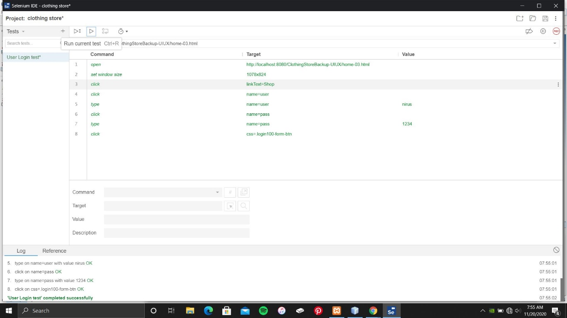

When the beginning of the testing, we have test the user login and user registration part. User login has successfully tested without any error.

2. **User Registration test**

When the first attempt of the user registration selenium has responded with a one error.

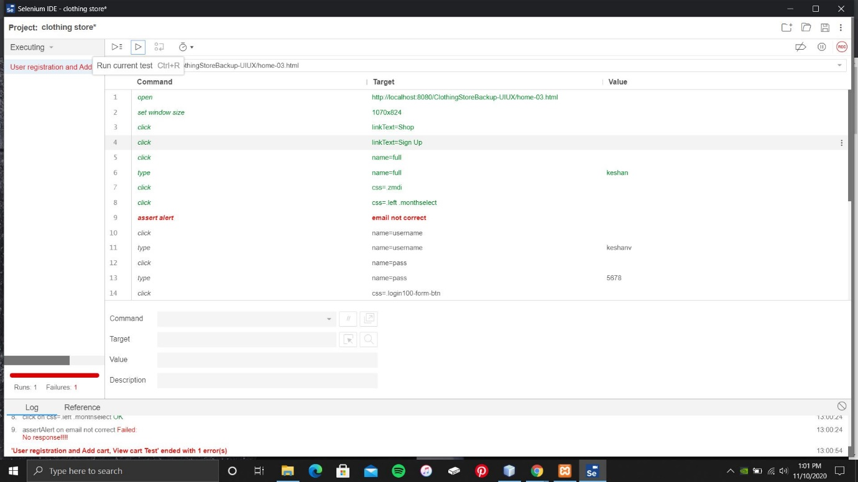

When the first attempt selenium has detected error on email not correct. Solution that we take for this error was fix the all email and password validation.

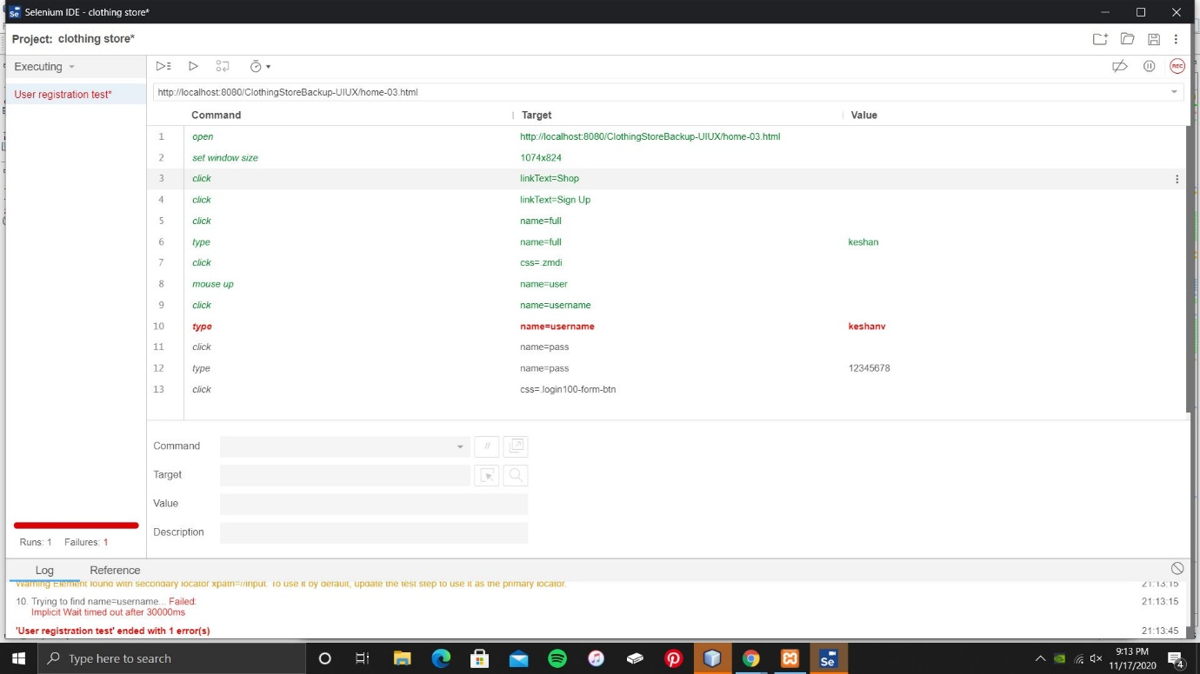

And after the second attempt selenium has responded with another error as well. The error was responded with the user registration username error. The reason the error appeared is 9th line same text box name was found on 10th line as well. So the solution that we took for this error was we changed the text box name into user.

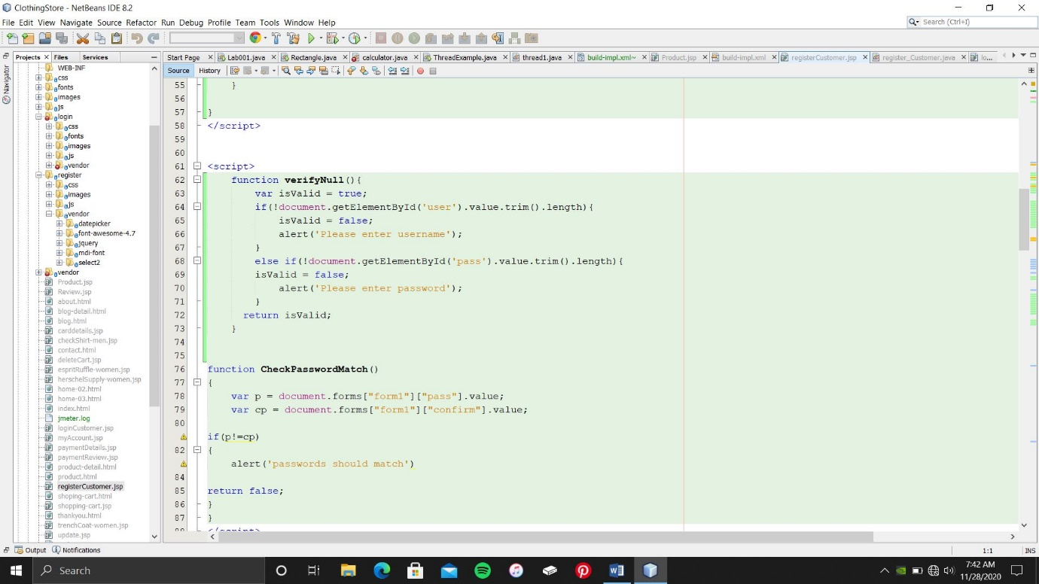

Registration input tag

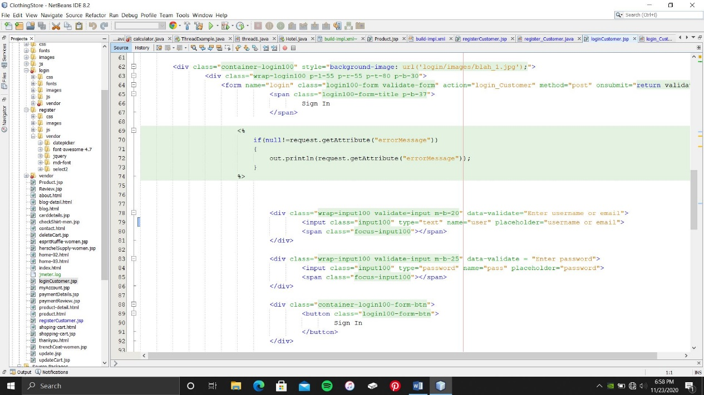

Changed text box name.

After the third attempt had registered a new customer and run the test cause, so the third attempt has been successfully run the test cause.

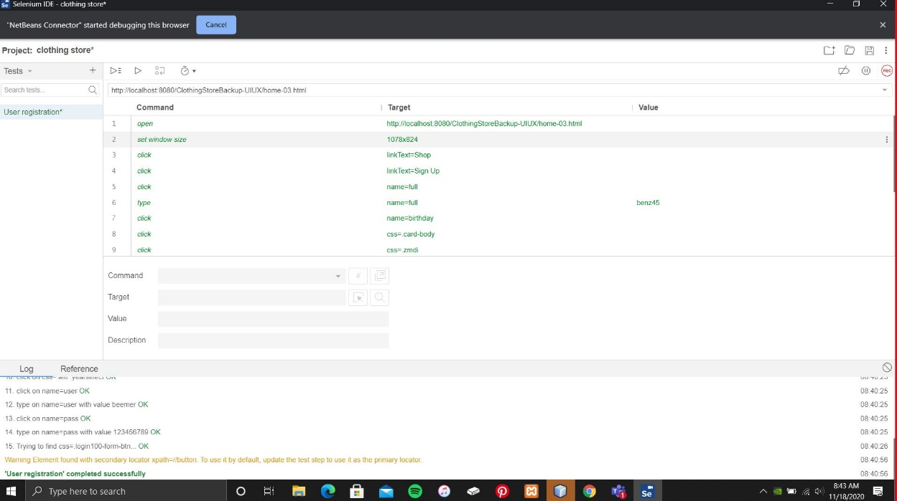

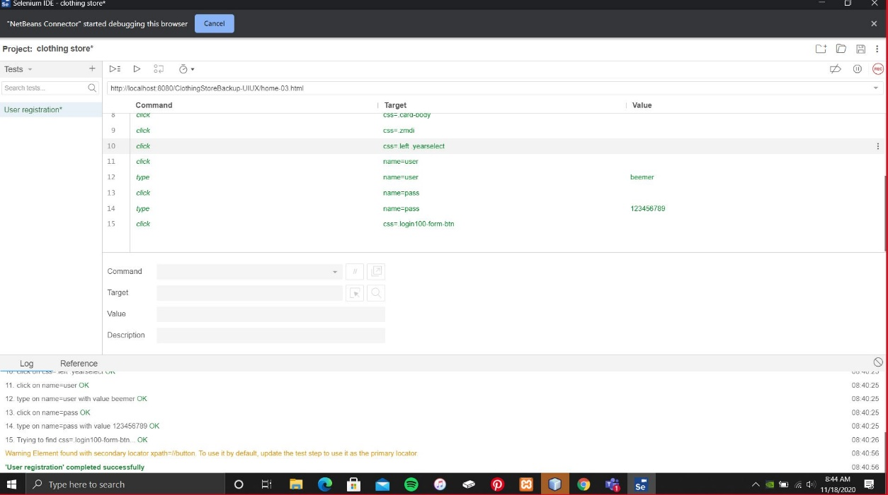

3. **User Registration validation test**

For the customer registration we have tested the all the validations on user registration form.

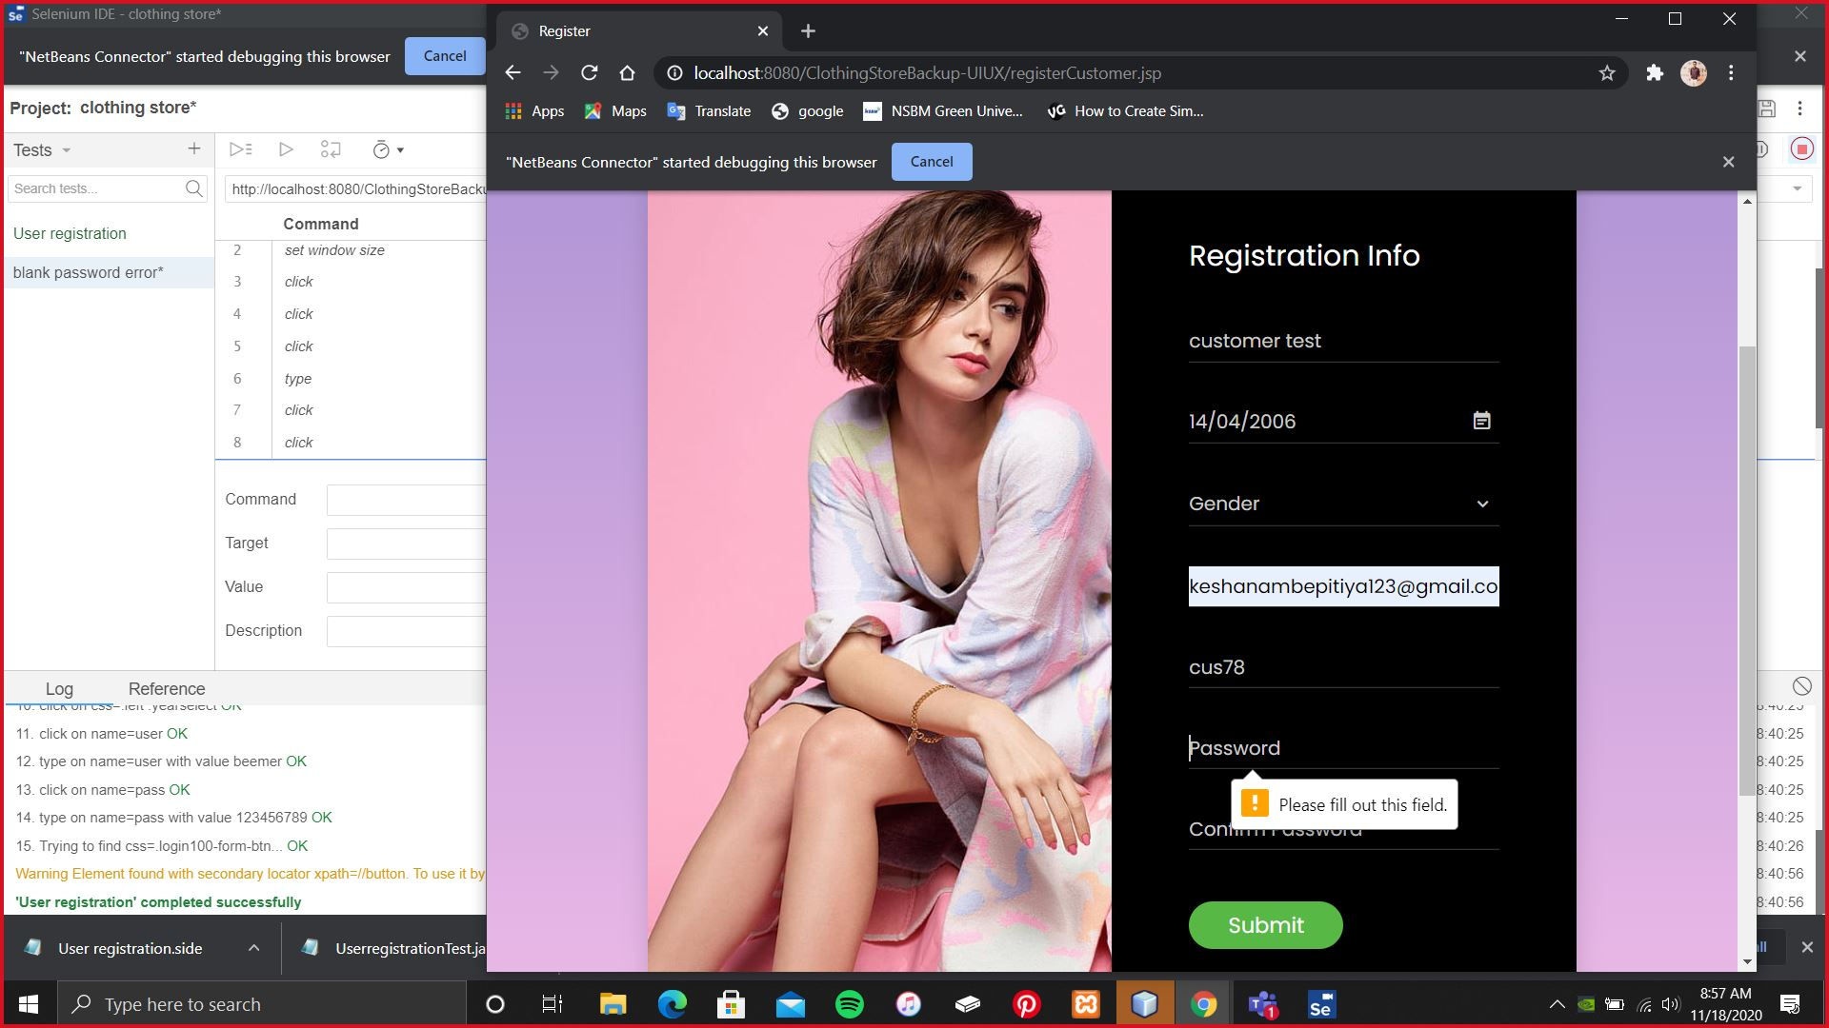

First validation part I have tested the click the submit button without password, the result was user registration form has indicate the ‘please fill out the field’ because of the user password is mandatory to new user registration.

Secondly we have tested the submit user password without a letter, in our system it’s mandatory to use more than 8 numbers and one letter. According to this validation part,

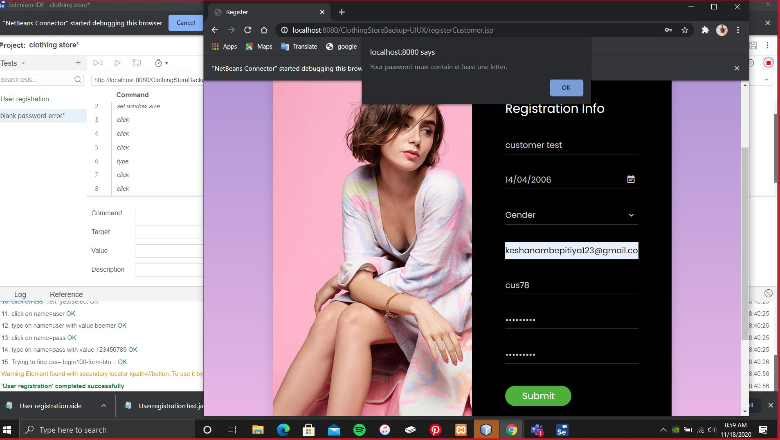

Localhost indicate a notification ‘your password must contain at least one letter’

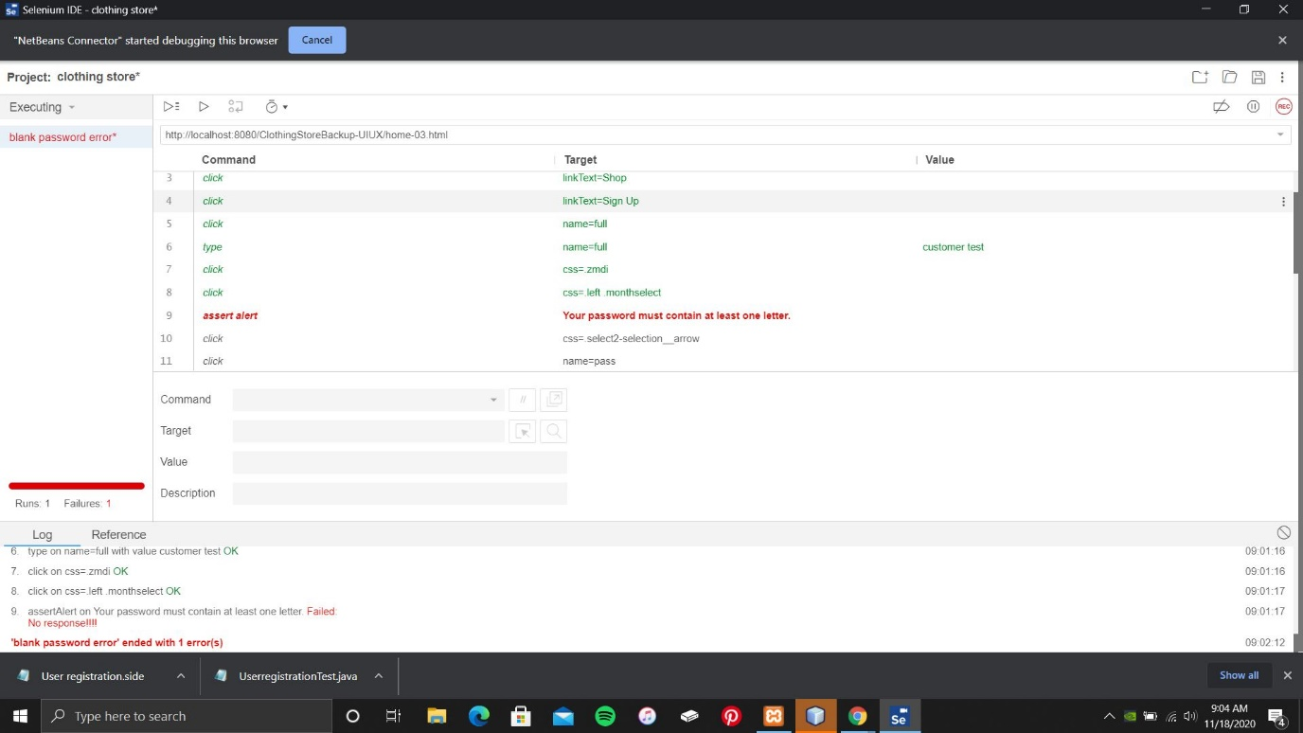

Above validation error has been also tested with the selenium IDE after run the test cause. According to the above tests all the functions and validations are success with system requirement as given.

4. **Add Cart View Cart test**

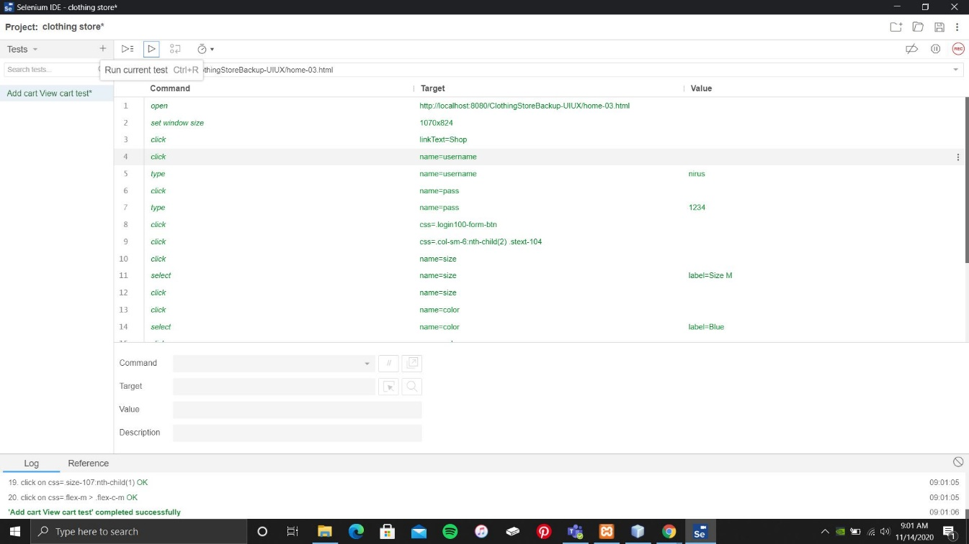

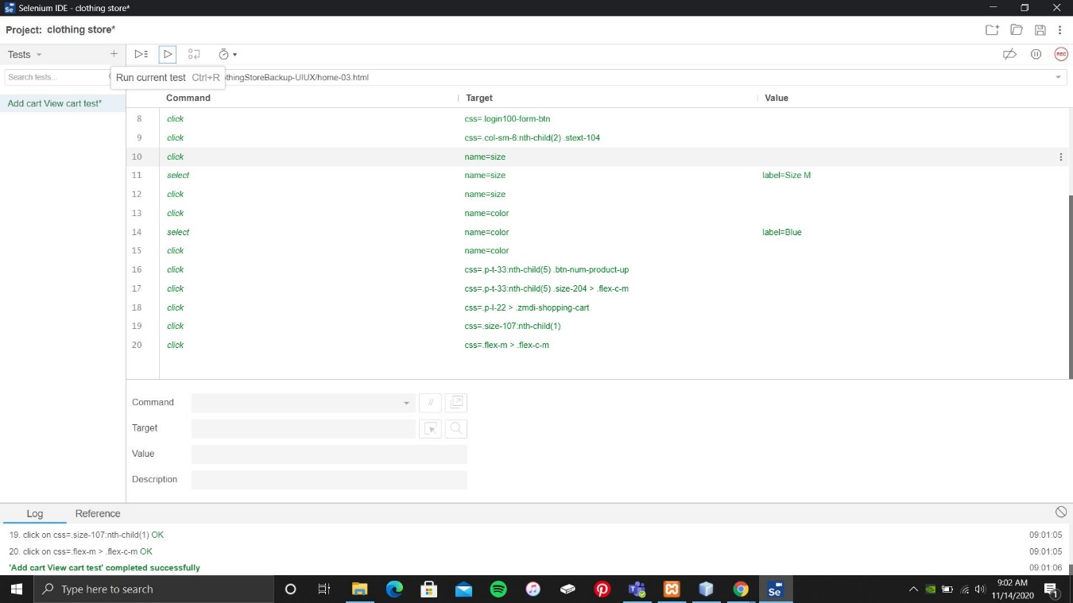

Add cart is when the user select item product as the customer satisfaction, user can select the product item, size of the product and color, after select the item user can be add to cart and view all the product items on view cart that customer selected.

5. **Update cart test**

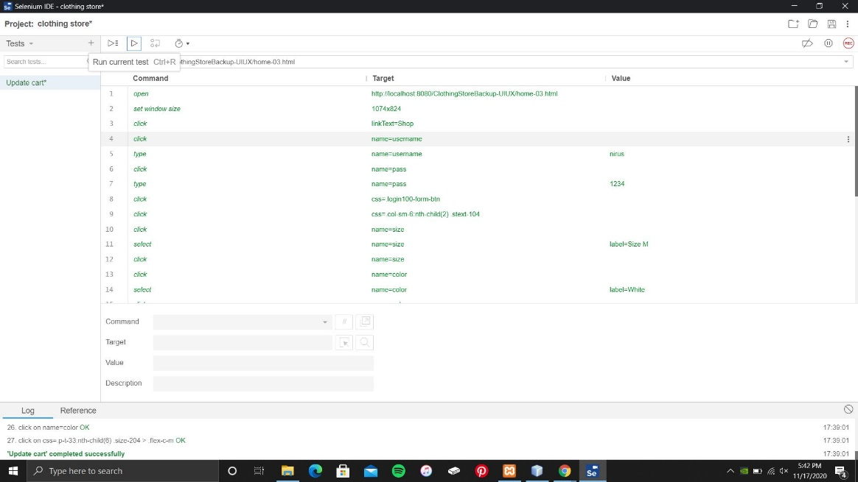

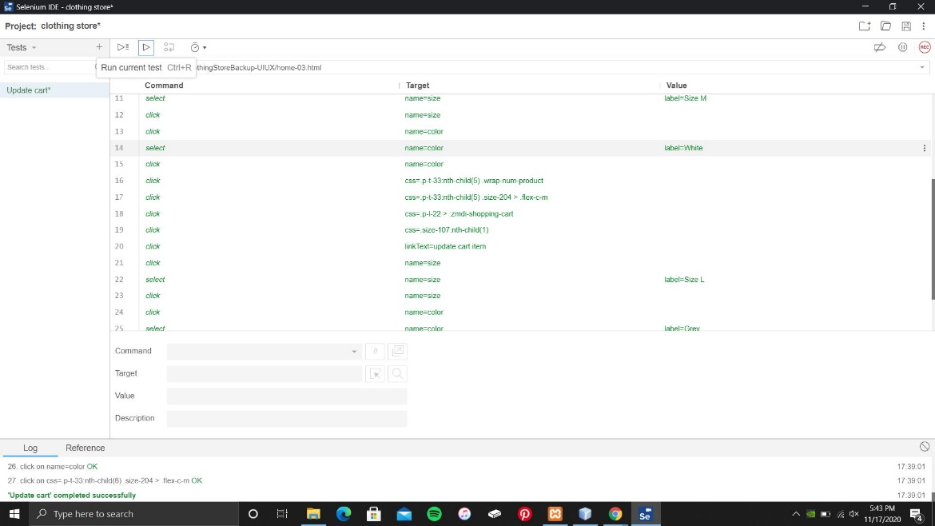

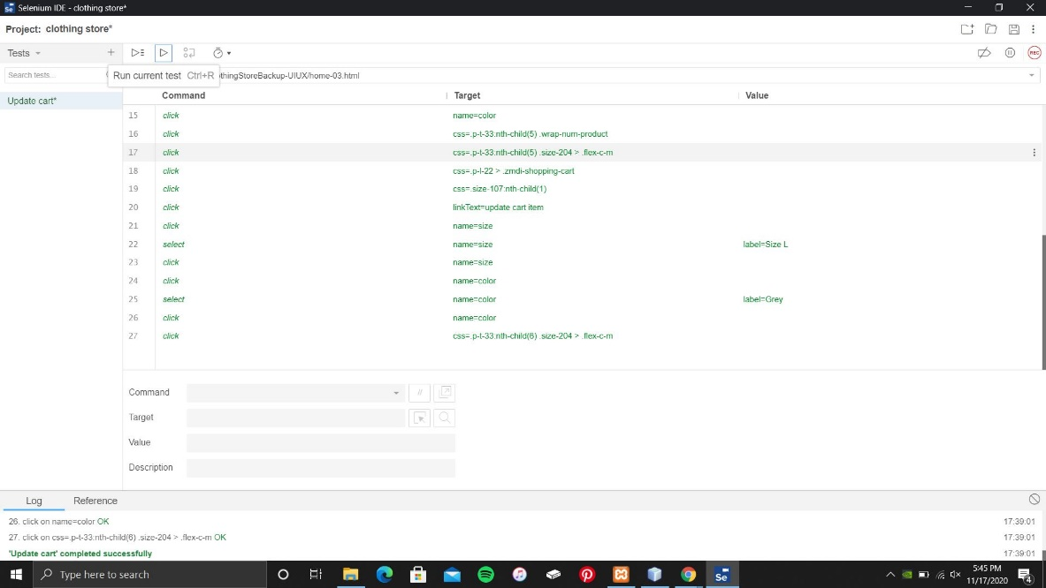

Update cart is when the customer select a product item, if the customer not satisfy with the product in view cart customer can update the product item into customer satisfying product. By update cart customer can update it into new product, size and color.

6. **Delete cart test**

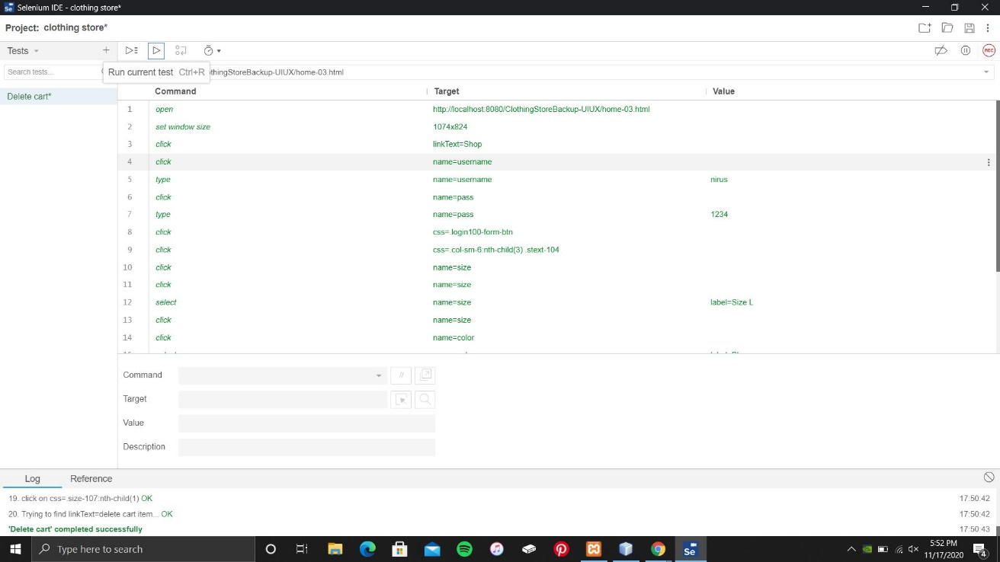

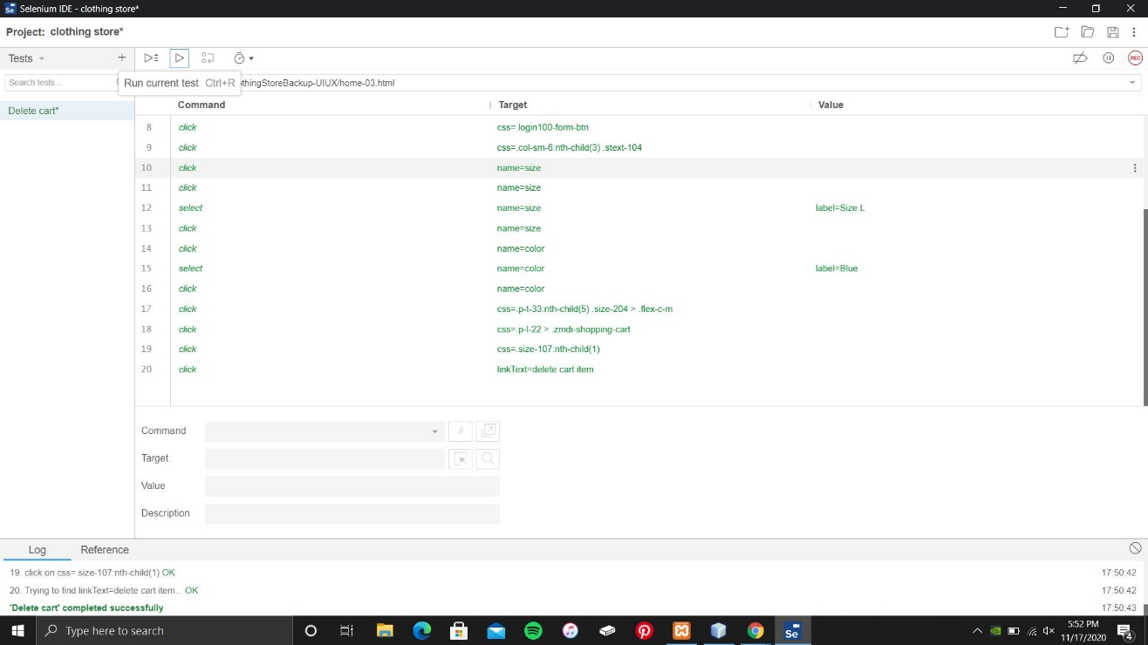

Delete cart was customer can be delete the selected product item if the customer not satisfy with the item.